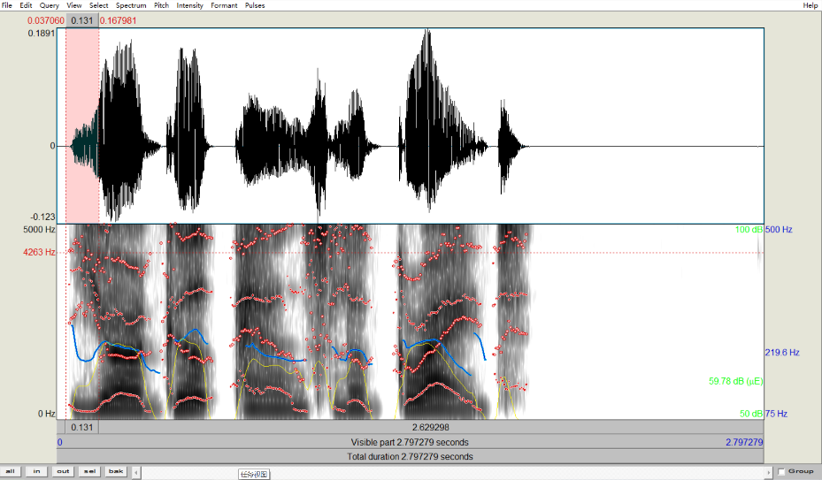

duration(sec.)

intensity (dB)

formant (Hz)

pitch (Hz)

* **Pitch**

“Your”-- duration (0.361451s) 219.6901596597805 Hz 177.0560074032698 Hz (min) 275.12931658816524 Hz (max)

“good”-- duration (0.202765s) 256.3450222104735 Hz 240.22974845290162 Hz (min) 272.0277738559549 Hz (max)

“pants”-- duration (0.387899s) 214.23553300702446 Hz 203.08080487521428 Hz (min) 240.84044531037847 Hz (max)

“look”-- duration (0.262765s) 215.3924958835363 Hz 194.62735593810916 Hz (min) 233.88164483071282 Hz (max)

“great” duration (0.524545s) 226.760685162987 Hz 171.55624817277217 Hz (min) 262.58332194931273 Hz (max)

**“Your good pants look great”**

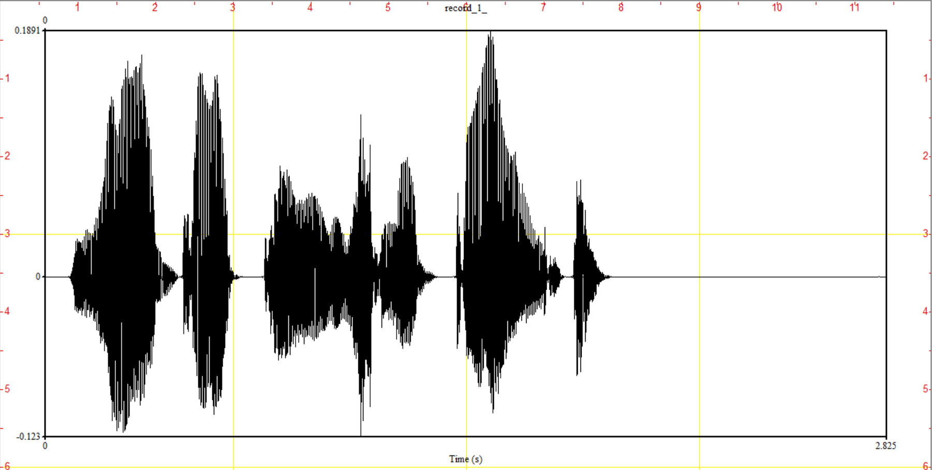

M

P

O

N

L

K

J

I

H

G

F

E

D

C

B

A

* **Your**

A: “y“ – approximant (0.095s 219.68141405451587 Hz) B: “ou” – vowel (0.200561s 231.9591057337133 Hz) C: “r” – stops (0.099s 197.0382333897702 Hz)

* **Good**

D: “g” – stops (252.2260050221915 Hz) E: ”oo” – vowel (0.090s 261.0036003645983 Hz) F: ”d” –stops (244.17766195186587 Hz)

* **Pants**

closure G: “p” – stops (234.67077888748574 Hz) H+I : “an” – vowel+nasal (0.218193s 234.67077888748574 Hz) J: “ts” – fricative (0.108s 204.44502069064723 Hz)

* **Look**

K: “l” – stops (213.06194368468212 Hz) L: “oo” – vowel (222.56130543611386 Hz) M: “k” – stops (208.85464239183642 Hz)

* **Great**

N: “G” – stops (238.7533080010804 Hz) O: “rea” – r+vowel (0.326188s 226.02768739272452 Hz) P: “t” – fricative (0.149870s)